
SYRIAN ARAB REPUBLIC | SYRIAN PRIVATE UNIVERSITY
Faculty of Artificial Intelligence Engineering
Software Engineering & Information Systems
GRADUATION PROJECT I / FIRST REPORT

Flower Trading Platform System
Problem and Objectives • State of the Art • Proposed Solution
Chapter One: Theoretical Study

PREPARED BY | SUPERVISED BY
Ahmad Raghib Al-Sayel | Dr. Kadan Aljouma
October 2026
REPORT OVERVIEW

Report Summary
This report introduces the Flower Trading Platform System and explains the problem it is intended to solve. It begins with the difficulties of handling flower orders through calls or scattered messages, then sets out the project objectives, looks at comparable online services, and outlines a possible system design. The theoretical chapter explains the concepts behind that design.
This report presents the analysis and conceptual design for Graduation Project I. The proposed functionality will be validated through requirements review, design refinement and subsequent implementation. External payment, delivery-service and image-search integrations remain optional extensions.
Report scope: The first-stage deliverable is a requirements and conceptual design study. Payment gateways, delivery-service integration and image-based search are optional extensions for later evaluation.

How the Report Is Organized
SECTION | CONTENTS
Part I: Project definition | Problem and objectives, state-of-the-art review, proposed solution, block diagram and flowchart.
Chapter One: Theory | E-commerce, user roles, databases, MVC, requirements, security and iterative development.
Conclusion and references | A conclusion and numbered references to the official flower-platform websites.
PART I / PROJECT DEFINITION

1. Problem Statement and Objectives

1.1 Background
Ordering flowers is usually tied to a particular occasion or delivery time. In a small shop, a customer might ask about a bouquet through a message, agree on the price by phone, and then contact the seller again to check whether the order is ready. Product availability, order details and delivery arrangements may be recorded in different places.
This creates problems on both sides. Customers do not always know what is available or where their order stands. Sellers have to repeat information and keep track of changes manually. The project focuses on connecting these steps rather than simply putting a flower catalogue online.

1.2 Engineering Problem
Main question: How can a web-based system with clearly defined user roles bring product information, inventory and order records together so that customers, sellers and administrators can work through the same reliable process?

1.3 Main Aim
To analyse and design an online platform that makes flower ordering easier for customers and gives sellers a more organized way to manage products and incoming orders.

1.4 Specific Objectives
• Present flowers and bouquets with useful photographs, prices and descriptions.
• Let customers register, search the catalogue, use a cart and submit orders.
• Give sellers or farmers tools to update listings, stock and order details.
• Provide administrative control over accounts, roles and permissions.
• Store product and order data in a structured database.
• Use an MVC-based design so the application can be maintained and extended.
• Study later options for delivery tracking, payments and image-based search.

1.5 Scope of This Report
The first report covers the engineering problem, project objectives, a review of comparable flower platforms, the proposed solution and its theoretical foundations. Detailed implementation, external integrations and performance evaluation belong to later project stages.
PART I / STATE OF THE ART

2. State of the Art

2.1 Comparable Flower Trading Platforms
This review examines three flower-commerce platforms through their official websites: BloomNation, Çiçeksepeti and LVLY. BloomNation connects customers with local florists [1, 2]. Çiçeksepeti documents flower selection, delivery details and order tracking [3]. LVLY provides personalised flowers and gift options [4]. These examples inform the catalogue, checkout and order-management requirements of the proposed system.

2.2 Comparison of Documented Features
PLATFORM | DOCUMENTED FEATURES | DESIGN IMPLICATION
BloomNation [1, 2] | Marketplace for bouquets made by local florists; delivery areas and fees are set by each florist. | Associate products with sellers and display delivery conditions clearly.
Çiçeksepeti [3] | Flower categories, delivery-date selection, address and card-note entry, and order tracking. | Use a structured checkout and make order status visible to the customer.
LVLY [4] | Personalised flower jars, optional gift additions and a personal card message. | Support gift messages and clearly defined customisation choices.
The comparison is based on information published on the official platform websites, accessed on 29 October 2026. It describes documented customer-facing functions; it does not assess internal architectures or independently measure service performance.

2.3 Implications for the Proposed Project
The project applies established flower-commerce patterns within a defined graduation-project scope. Its contribution is an integrated design for customer ordering, seller-managed inventory and administrator access, with explicit data relationships and order states. This is a design focus, rather than a claim that the reference platforms lack these capabilities.

2.4 Requirements to Carry into the Design
• Keep the catalogue straightforward and easy to search.
• Let authorized sellers update their own product and stock data.
• Show clear order states to both customers and sellers.
• Keep administrator permissions separate from ordinary user actions.
• Design optional integrations so they can be added later without changing the entire system.
PART I / PROPOSED SOLUTION

3. Proposed Solution

3.1 How the System Would Work
The proposed platform is a website shared by customers, sellers or farmers, and administrators. Sellers publish flowers and bouquets and keep their listings up to date. Customers can browse the catalogue, add items to a cart and submit orders. Administrators manage accounts and access rights. The different parts use the same data so that one action does not have to be entered again somewhere else.

3.2 High-Level Block Diagram
Figure 1 presents the proposed application layers: a user interface, request-handling controllers and a shared data layer. It identifies the responsibilities and main information exchanges that will guide detailed design.
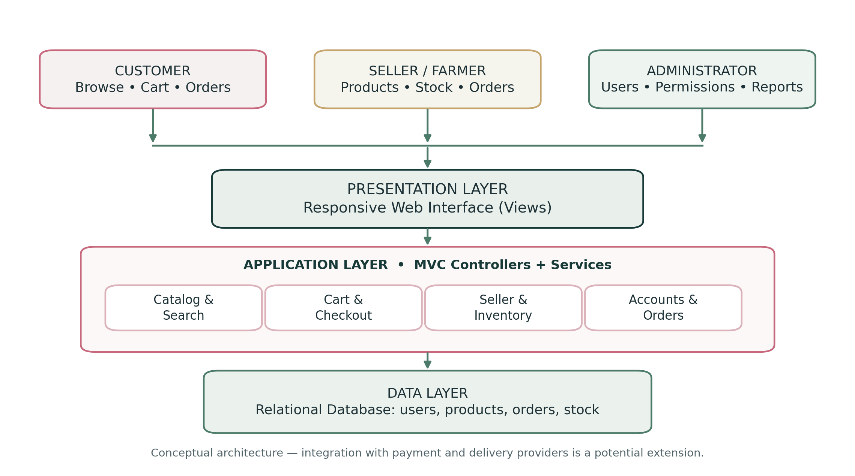
Figure 1. Proposed high-level block diagram.

3.3 Main Components
COMPONENT | FUNCTION
Catalogue and search | Show flower images, descriptions, prices and search results.
Cart and orders | Collect item selections and create order records.
Seller management | Update products and stock and review incoming orders.
Accounts and roles | Control sign-in and actions available to each user type.
Database | Keep consistent records for users, products, orders and status updates.
PART I / ORDER WORKFLOW

4. Order Flowchart
Figure 2 follows a customer order from product selection to an updated order status. After browsing the catalogue, the customer confirms the cart and submits an order. The system checks availability. If the item is unavailable, the customer needs to change the selection; otherwise, the seller reviews and prepares it. This is a simplified flow, to be refined when the detailed requirements are agreed.
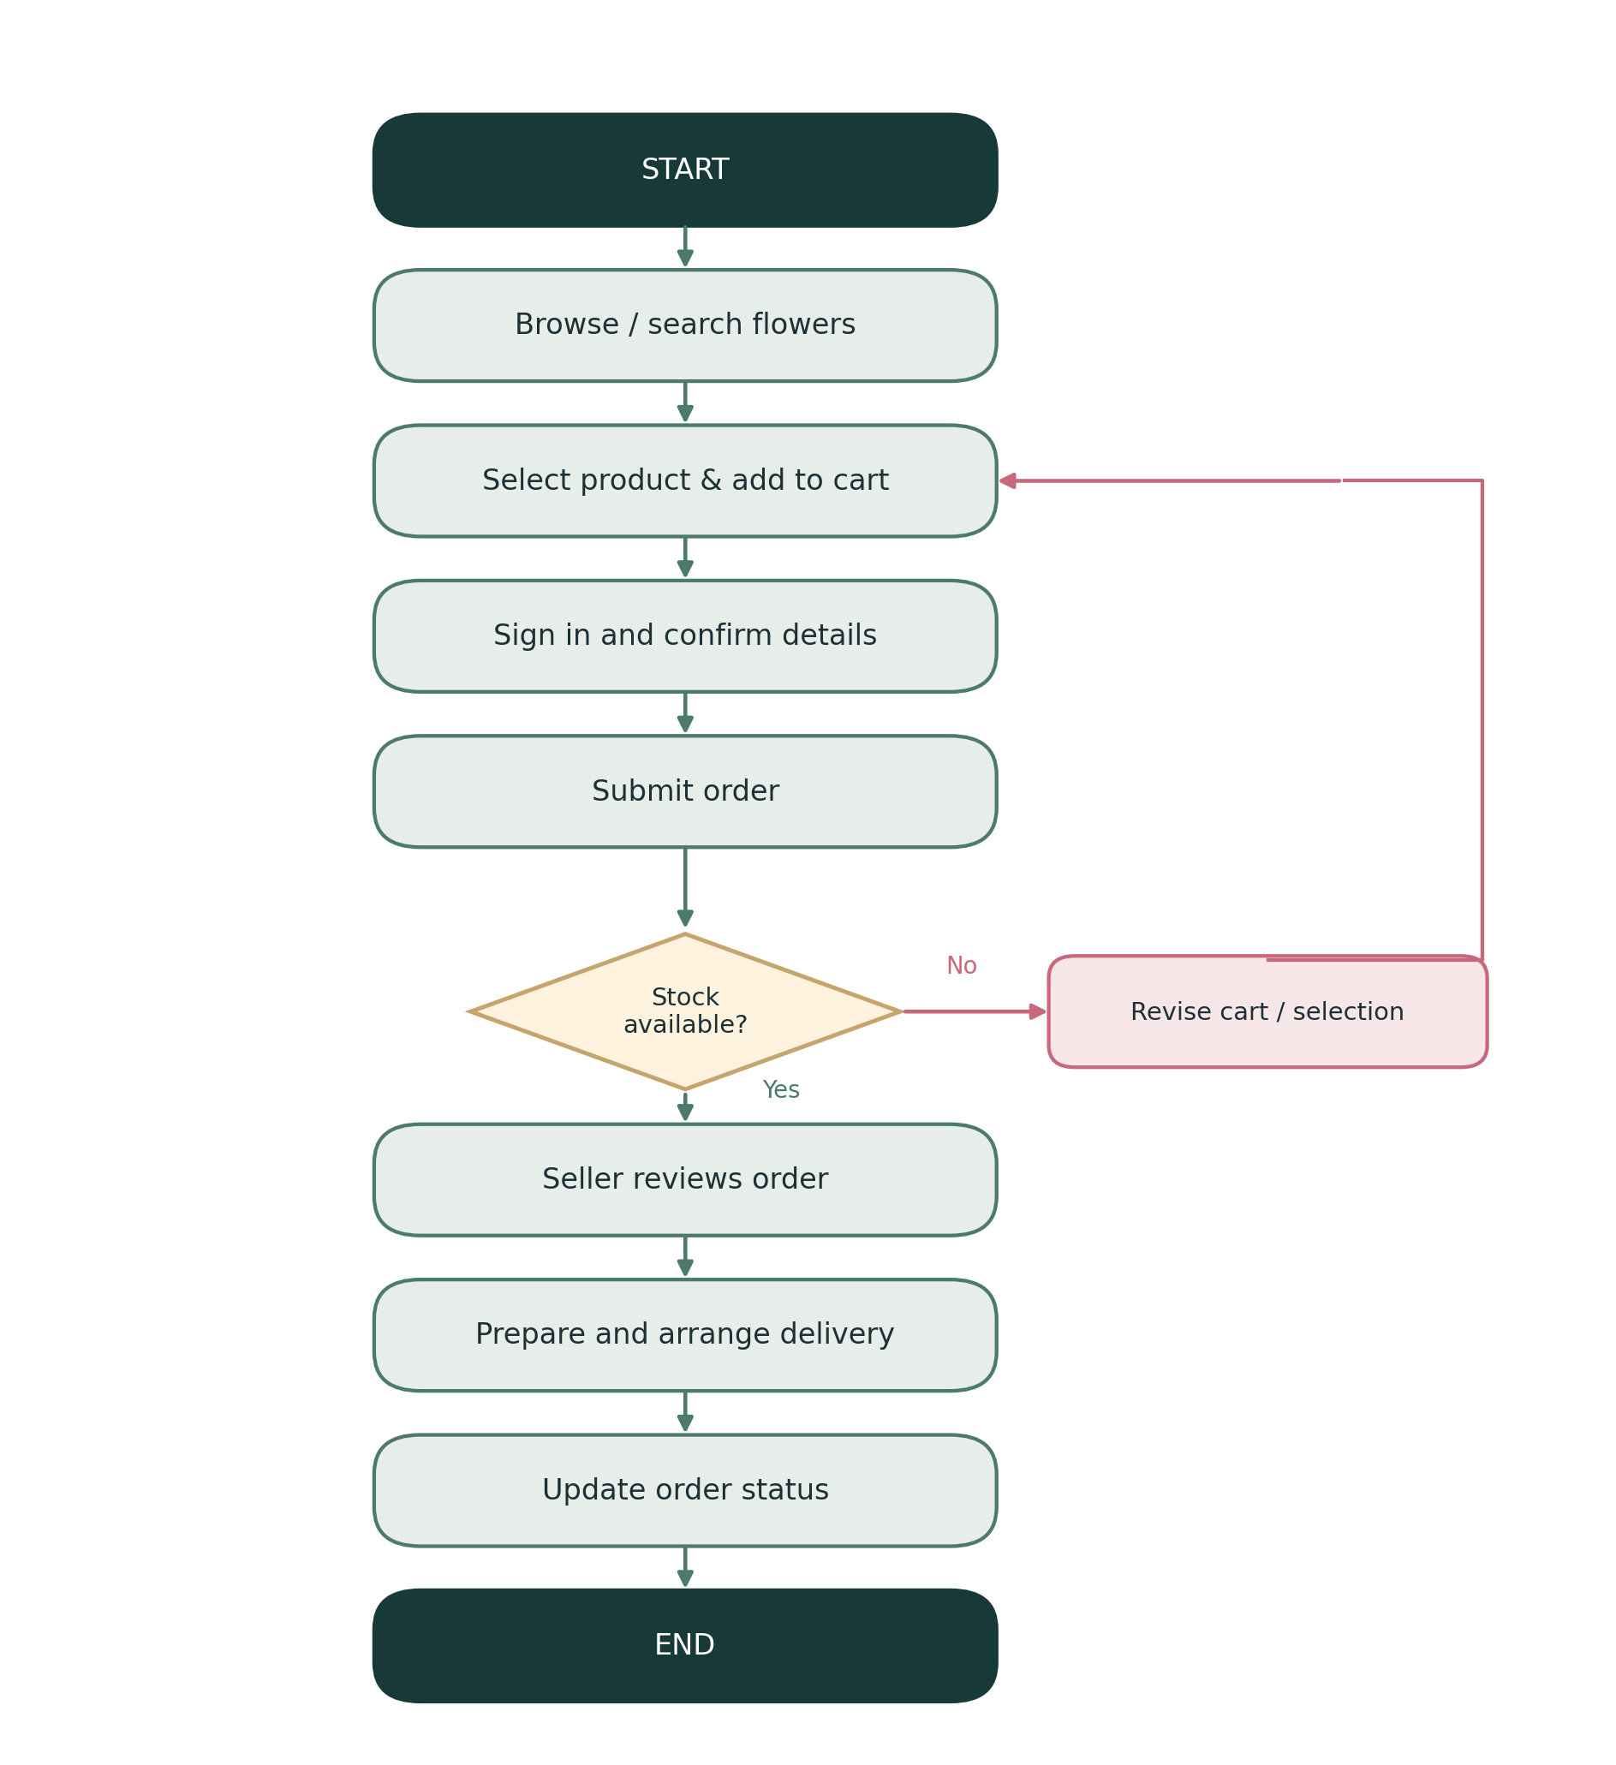
Figure 2. Simplified flower-order flowchart.
CHAPTER ONE / THEORETICAL STUDY

Chapter One: Theoretical Study

1.1 Introduction
The theoretical study defines the concepts required to analyse and design the proposed platform. E-commerce, information systems, access control and application architecture provide the basis for connecting product selection, inventory management and order processing in one system.

1.2 E-Commerce and Online Marketplaces
E-commerce is the buying and selling of products through digital services. An online marketplace can bring several sellers and their product catalogues into one place. In the flower platform, customers would be able to compare bouquets, while each seller remains responsible for the products they offer.

1.3 Information Systems and Data Flow
An information system combines people, procedures, software and stored data. For example, when a customer submits a flower order, the website sends the selected products and customer details to the application. The application checks the information, stores the order and returns a response to the right users.

1.4 User Roles and Permissions
Role-based access control (RBAC) limits actions according to the user’s role. A customer should not edit a seller’s stock, and a seller should not have unrestricted access to administrator functions.
ROLE | MAIN ACTIONS
Guest | Browse available products and create an account.
Customer | Search, save favourites, use a cart and manage own orders.
Seller / Farmer | Manage own listings, stock and incoming orders.
Administrator | Manage users, sellers, roles and permissions.

CHAPTER ONE / ARCHITECTURE AND DATA

1.5 MVC Architecture and Database Design

1.5.1 Model–View–Controller
The MVC approach separates the application into three parts. The Model represents data and the rules that apply to it. The View is what users see and interact with. The Controller receives requests and coordinates the necessary work. This separation matters when the same platform has customer pages, seller tools and an administration area.
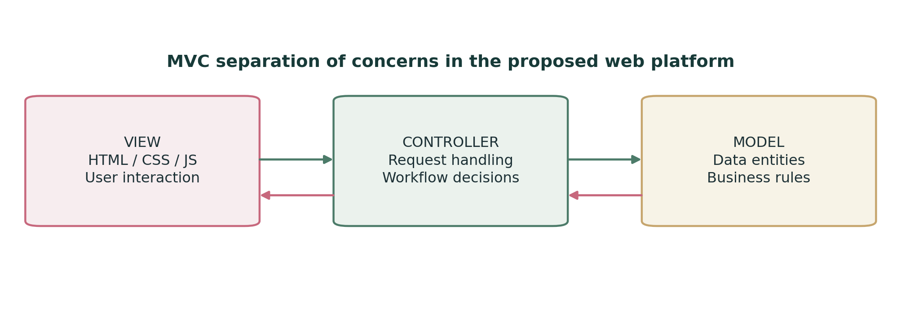
Figure 3. MVC responsibilities in the proposed website.

1.5.2 Relational Database
A relational database organizes data into related tables. Rather than placing every piece of information in one record, the platform can keep users, sellers, products, orders and order items separate. This also allows an order to retain its original product price even if the catalogue price changes later.
ENTITY | EXAMPLE INFORMATION
User | ID, name, login details and role.
Seller | Store name and associated user account.
Product | Name, description, price, stock and seller reference.
Order | Customer reference, order date and status.
Order item | Product reference, quantity and price at purchase.

1.5.3 UML and System Models
UML diagrams describe the system from complementary perspectives. Use-case diagrams identify actor interactions; activity diagrams describe process steps; sequence diagrams show interaction order; and class diagrams define the main software structures. An entity-relationship diagram (ERD) supports database design. These models will be refined against the agreed requirements.
CHAPTER ONE / REQUIREMENTS AND DEVELOPMENT

1.6 Requirements and System Quality

1.6.1 Functional and Non-Functional Requirements
Functional requirements describe tasks the system must perform, such as adding a flower, searching the catalogue or submitting an order. Non-functional requirements deal with qualities such as ease of use, access control, reliability and maintainability. Both types should be specific enough to test later.

1.6.2 Iterative Development
The proposed development process is iterative. Work is divided into manageable versions, beginning with accounts and product listings, followed by the cart, order processing, seller tools and administrator permissions. Each iteration includes implementation and testing against its requirements before further functionality is added.

1.6.3 Security and Reliable Orders
The website would hold account information and order records, so users need secure authentication and checks on what they are allowed to do. Form input should be validated, and sensitive data should be protected. Order creation and stock updates also need to agree with each other; otherwise, a customer may receive an order confirmation for an item that cannot be supplied.

1.6.4 Usability
Flower images, prices, categories and the steps of checkout should be easy to understand on both computers and phones. Clear error messages are important, especially when information is missing or an item is no longer available. The aim is to make the common tasks straightforward, not simply to produce attractive pages.

1.6.5 Features for Future Study
Optional extensions include image-based flower search, automated order notifications, and payment or delivery-service integrations. Each extension requires defined requirements, suitable interfaces and independent testing before it can be included in the implemented system.
Chapter summary: The project is built around a role-based website and a consistent database. MVC, requirements analysis, system models and iterative testing provide a practical basis for the next design and implementation steps.

CONCLUSION AND REFERENCES

Conclusion
This first report defines the engineering problem, objectives and conceptual solution for the Flower Trading Platform System. The review of official flower-platform websites identifies design considerations for catalogue browsing, delivery information and personalisation. The block diagram and order flowchart describe the proposed structure and workflow, while Chapter One establishes the theoretical basis for further development.
The next phase will specify and validate the detailed requirements, refine the use cases and data model, and implement a testable core system. Evaluation will focus on correct order processing, inventory consistency, role-based access and usability across common devices.

References
[1] BloomNation. About Us. [Online]. Available: https://www.bloomnation.com/about-us/. Accessed: 29 October 2026.
[2] BloomNation. Delivery Policy. [Online]. Available: https://www.bloomnation.com/delivery-fee-and-taxes/. Accessed: 29 October 2026.
[3] Çiçeksepeti. Çiçek Siparişi ve Çiçek Gönder (Flower Ordering and Delivery). [Online]. Available: https://www.ciceksepeti.com/d/cicek. Accessed: 29 October 2026.
[4] LVLY. Personalised Gifts and Flowers. [Online]. Available: https://www.lvly.com.au/collections/personalised-gifts. Accessed: 29 October 2026.

